Annex C – Technical
FIRST DRAFT

Document No:

Issue Date:
Classification:

Documentation security classification applies to this document

i Document Authorization
Reviewed by | Approved by
Name:  Date:  Signature: | Name:  Date:  Signature:

ii Revision History
The following is a brief summary of the most recent revisions to the document. Details of all revisions prior to these are held by the issuing department.
Revision No. | Date | Author | Scope / Remarks
1.01 | 12.01.2023 |  | Second Draft incorporating TRA Comments
1.02 | 26.01.2023 |  | Data Centre Revision
1.03 | 23.02.2023 |  | Duct Access Added
1.04 | 26.03.2023 |  | Modified to First Draft

Table of Contents

1 Purpose and Scope 3
2 Definitions 4
3 Oman Broadband’s Fibre Network 5
4 Data Centre 7
5 Feeder Area 9
6 Distribution Area 11
7 Customer Area 12
8 Tag Codes 13
9 B2B Gateway 14

Purpose and Scope

This Annex sets out the technical architecture and key characteristics of Oman Broadband’s fibre-optic network.

This Annex also presents the tools used to describe Oman Broadband’s footprint and covered Premises, as well as the available automation tools that can be used to order and manage Oman Broadband’s services.

This Annex is for information purposes only. Some of the information may be dated and may not reflect the most current technical developments, engineering design or tools at Oman Broadband.

Definitions

See Definitions in Annex A of the Agreement.

Oman Broadband’s Fibre Network

Oman Broadband’s Fibre Network comprises of two parts:

Access Network that includes components required by Oman Broadband to provide its FTTH services such as BEUC and DCTB; and

Other Network which may be used by Oman Broadband to offer other services.

This Agreement only covers services related to Oman Broadband’s Access Network, and the services related to the Other Network are not covered as a part of this Agreement. Therefore, any mention of Network in this Agreement solely refers to Oman Broadband’s Access Network.

Oman Broadband has deployed a passive optical network (PON) within Oman, which is used by Requesting Licensees to offer fibre-based broadband Internet access to End-Users located in the areas covered by Oman Broadband’s fibre network.

Oman Broadband owns, operates and maintains all passive infrastructure such as trenches, ducts, cabinets, chambers/handholes, fibre optic cables and certain active equipment to enable service provider connectivity.

Oman Broadband’s fibre network architecture follows international best practice and consists of the Feeder, Distribution and Customer areas. Oman Broadband’s network includes the fibre-optic cables connecting Data Centre sites to FDHs, FDHs to NAPs, and NAPs to CAPs as illustrated in Figure 1.

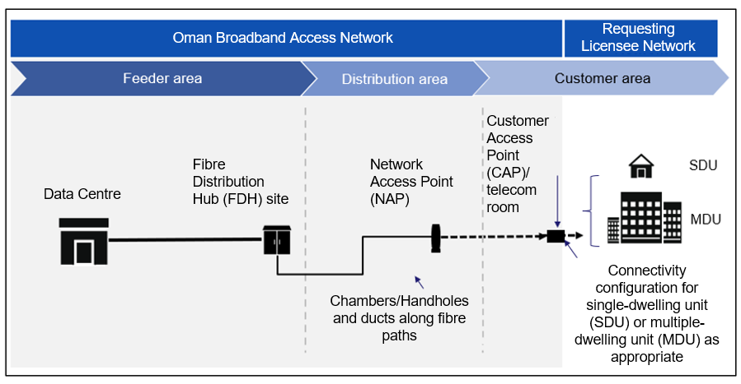
Figure 1: Overview of Oman Broadband Access Network architecture

Oman Broadband’s network demarcation point is the:

CAP in case of BEUC Service; and

CAP or the telecom room in case of DCTB Service.

For the avoidance of doubt, the Optical Network Terminals (ONTs) deployed by Requesting Licensees in the Single Dwelling Units (SDUs) and Multi-Dwelling Units (MDUs) are not part of Oman Broadband’s network.

Oman Broadband’s Access Network generally does not use Sub-Ducts, although there could be exceptions. However, Sub-Ducts are offered to Requesting Licensees as part of the Duct Access Service.

Data Centre

Oman Broadband’s Data Centre sites are deployed across Oman Broadband’s network to host the Optical Distribution Frame (ODF) and to provide the power required by the active equipment deployed inside the Data Centre site (including Requesting Licensee’s active equipment).

ODFs are used to provide:

Opportunities for rearrangement (i.e., future flexibility);

Patching;

Access for fibre optic cable testing.

Data Centre sites host Requesting Licensees’ active equipment, such as Optical Line Terminals (OLTs), to enable Requesting Licensees to offer their own broadband services to End- Users.

Data Centre sites are usually equipped with the following, as per the standard Oman Broadband design:

an air conditioning system on an N + N basis with set run times;

an FM200 fire suppression system (or equivalent) operating on a dual-incident basis;

a CCTV and access control security system;

an Uninterruptible Power Supply (UPS) rectifier system, to convert the three-phase 440V mains electricity supply to a Direct Current (DC) supply as used by telecommunications equipment (54V DC nominal);

a back-up battery, in certain cases;

a Fibre Monitor System, to monitor the fibre network on a real-time basis;

a site management system for environment monitoring, to collate and report in real-time on events associated with (but not limited to) the above environmental, security and monitor systems;

cable management systems, to manage the distribution of optical cables, DC cables and optical patch cords within the equipment room.

Oman Broadband’s network contains different Data Centre site types including permanent structures/buildings, shelters, cabinets, among others. Shelters and semi-permanent structures are more common in less populated areas. Data Centre sites which are buildings usually host three (3) to five (5) dedicated cages while the shelters are more commonly used as shared co-location spaces.

In the case of Data Centre sites of the type permanent structures/buildings, the overall structure of the Data Centre is constructed from reinforced concrete and may be a single-floor or double-floor structure.

The design of the Data Centre sites considers the environmental conditions as applicable to Oman and each Data Centre is designed to have a minimum life span of 25 years.

Feeder Area

The Feeder Area extends from the ODF, which is located within the Data Centre site, to the distribution points located within the Fibre Distribution Hubs (FDHs).

The Feeder Area includes network elements such as trenches and ducts, fibre-optic cables, chambers/handholes, splice joints and FDHs.

The feeder cable architecture provides physically diverse fibre delivery to a number of FDH street cabinet locations.

The optical splitter system resides in FDHs. The FDHs are the site of a single-stage 1:32 way splitter array, which sometimes have diverse physical paths to the Data Centre site.

FDHs are deployed throughout Oman Broadband network to connect the feeder cable installed in ducts along the Feeder Area (originating at the Data Centre site) to the distribution cable feeding the Network Access Point (NAP) in the Distribution Area.

The FDH will serve as a distribution point from the Data Centre site and will contain a minimum of fifteen (15) × PON splitters at 1:32.

The FDH normally serves a maximum of 480 Premises.

In the Feeder Area, Oman Broadband uses fibre-optic cables of different sizes, such as:

432 fibre cores;

288 fibre cores;

144 fibre cores;

96 fibre cores;

48 fibre cores;

24 fibre cores.

FDH deployments are protected against accidental damage from vehicles by the installation of FDH protection posts.

Chambers/Handholes are hollow structures positioned along the route of fibre-based networks, usually underground, to provide for the following requirements:

pulling of cable along the route of the network;

accommodation of spare lengths of cable (coiled cable) to allow for future repairs;

splicing of joints;

facilitation of directional changes in the network route;

accommodation of the NAP;

provision of customer connections (i.e. in Oman Broadband’s case, a chamber/handhole can accommodate 25mm secondary ducts).

Fibre-optic cables from the Data Centre site to the FDH, from the FDH to the NAP, and from the NAP to the CAP are installed within ducts which are themselves installed within trenches. The type of duct installed will vary along the network, and there may be multiple ducts used in more central parts of the network in order to house a higher number of fibre-optic cables. On occasions, fibre-optic cable in the feeder may be installed as aerial cable using telecommunication or electrical poles.

Distribution Area

The Distribution Area connects the FDH splitter with the NAP, which is the main distribution point for the customer distribution cables.

The distribution cable architecture provides non-redundant and tapering fibre delivery to a number of NAPs in underground chamber/handhole locations.

Each NAP in the Distribution Area can support SDUs or MDUs, including several tenancies in a single building.

A 25mm conduit is pre-installed from the NAP to the boundary wall of End-User’s Premises.

When an order to activate an End-User (Connect Order) is received, then:

The 25mm conduit is extended from the boundary wall to the Premises exterior wall;

A CAP is installed inside the Premises;

Fibre cables are installed from the NAP to the CAP;

A fibre patch cord is installed at the FDH to connect the distribution fibre to a splitter port.

Each Premises will have a drop cable provided to the NAP; at least one of these fibres will be spliced through to the cabinet housing the splitters (FDH).

An NAP may also act as a splice joint for the division of the cable or reduction in cable size.

In the Distribution Area, Oman Broadband uses fibre-optic cables of different sizes, such as:

288 fibre cores;

144 fibre cores;

96 fibre cores;

48 fibre cores;

24 fibre cores;

12 fibre cores;

4 fibre cores;

2 fibre cores.

Customer Area

The Customer Area consists of a drop cable that connects the NAP to the Customer Access Point (CAP) and a patch cord to connect the CAP to the optical network terminal (ONT) in the Customer Premises.

The patch cord to connect the CAP to the ONT in the Customer Premises, either an SDU or MDU, is not part of Oman Broadband network.

The required number of fibre cores will be terminated at the Customer Premises on a four-ports termination box and will be present on Subscriber Connectors (SCs) or Angled Physical Contact (APC) Connectors.

Tag Codes

Oman Broadband has created a system that uniquely identifies properties where its network has been rolled out.

Each building within the footprint has been identified with a unique Tag Code, which is used as part of the ordering and fault management systems.

The Tag Code should be used as an alternative to a physical address, since the address is not always unique.

The Tag Code is defined in Military Grid Reference System format, which is a fifteen (15) character code containing both digits and letters, e.g., 40QFM4038710906.

The format is recognised by Earth browsers (such as Google Earth™) and may be located using relevant Geographic Information Software (GIS) applications.

It should be noted that Tag Codes define the building within the footprint, but do not necessarily define each tenancy. For example, in the case of MDUs there may be many tenancies within the same building. For this reason, Oman Broadband may add a suffix to the Tag Code at the time an order is placed e.g., 40QFM4038710906/12, where the suffix ‘12’ denotes that this is the 12th tenancy within the building. In the case of a single villa, the suffix would always be ‘1’, e.g., 40QFM4038710906/1.

The Tag Codes are available in various formats, such as Microsoft Excel™ (xlsx), Geodatabase format (gdb) and Zipped Keyhole Markup Language for Earth browsers (kmz). The list of Tag Codes is shared with all Requesting Licensees prior to the release of an expansion of Oman Broadband’s footprint for a relevant area.

Each Tag Code is also provided with attributes that provide more details on the building. Such attributes may include the type of property (e.g., single villa or MDU), building and way numbers, and, in the case of an MDU, details of the number of apartments within the building.

B2B Gateway

Oman Broadband provides a B2B Gateway for use by Requesting Licensees to place orders, raise Trouble Tickets and provide status updates.

The B2B Gateway is provided using web-based Application Programming Interfaces (APIs) and specifications for these will be made available to Requesting Licensee on request.

This capability is currently available only for Basic End-User Connection (BEUC) Services.

Processes for managing other Regulated Services will become more automated in the future. Consequently, the B2B Gateway may become useable for additional Regulated Services (e.g., Direct Connectivity to the Building Service), depending on the planned volumes and requirements of Requesting Licensees.

