

Annex D – ORDERS, SERVICE ASSURANCE AND SERVICE PERFORMANCE
FIRST DRAFT

Document No:

Issue Date:
Classification:

Documentation security classification applies to this document

i Document Authorization
Reviewed by | Approved by
Name:  Date:  Signature: | Name:  Date:  Signature:

ii Revision History
The following is a brief summary of the most recent revisions to the document. Details of all revisions prior to these are held by the issuing department.
Revision No. | Date | Author | Scope / Remarks
1.01 | 12.01.2023 | Paul France | Incorporated TRA Comments
1.02 | 26.01.2023 | Paul France | Data Centre Revision
1.03 | 23.02.2023 | Paul France | Duct Access Added
1.04 | 26.03.2023 | Paul France | Modified to First Draft  Outdoor Colocation added
2.01 | 15.09.2023 | Paul France | Modified to Second Draft
2.02 | 19.09.2023 | Paul France | Updates to Second Draft
2.03 | 29.10.2025 | Said Al Salami | Final (2nd Draft RAIO)

Table of Contents

1 Purpose and Scope 3
2 Definitions 4
3 Service Orders: Basic End-User Connection (BEUC) 5
5 Service Orders: Co-location 23
7 Service Orders: Duct Access 25
8 Raising a Trouble Ticket 27
9 Service Ordering and Provisioning/Delivery KPIs and SLGs 40
10 Fault Reporting/Repair KPIs and SLGs 44
11 Minimum QoS KPIs and SLGs 48
12 Billing KPIs and SLGs 50
13 Network Operation and Maintenance 51
14 Procedures for non-compliance to SLGs 52

Purpose and Scope

This Annex sets out the processes and procedures that apply to the operational aspects of the supply of Regulated Services by Oman Broadband to Requesting Licensee under this Agreement.

This Annex covers operational processes such as:

placing different types of Orders (Connect, Modify, Disconnect, Cancel);

raising trouble tickets;

exchanging notifications between Oman Broadband and Requesting Licensee; and

measuring service performance and service assurance for Regulated Services provided to Requesting Licensee.

Definitions

See Definitions in Annex A of the Agreement.

Service Orders: Basic End-User Connection (BEUC)

Types of Provision Orders for BEUCs

There are five types of orders which may be placed for BEUC Service:

Connect Order: a basic request for a new connection for End-User;

Connect with ONT: a variation of the Connect Order where the installation and activation of the Optical Network Terminal (ONT) is also included;

Modify Order: a request to modify the network within End-User’s Premises (e.g. relocation of Customer Access Point (CAP) or the fibre cable within the Premises);

Cancel Order: a request to cancel an In-Flight Connect or Modify Order prior to completion;

Disconnect Order: a request to terminate service for End-User connection.

There are four End-User types who might be required to provide specific proof of identity:

Residential: End-Users may prove that they form part of the Residential category by providing a Residential ID;

Business: End-Users may prove that they form part of the Business category by providing a Business CRN in the Order request;

Health and Education: Justification for Health and Education orders must be provided to Oman Broadband Commercial Affairs team before such orders will be accepted;

Riyadh Connection: Justification for Riyadh orders must be provided to Oman Broadband before such orders will be accepted.

Placing a BEUC Connect Order

The information required by Oman Broadband to deliver a Connect Order for a BEUC Service is shown below.
Field | Description
Product* | BEUC
Order Type* | Connect Or Connect with ONT
End-User type* | Residential, Business, Health and Education, and Riyadh
Tag* | The Tag identifier obtained from the GIS files of the footprint
Requesting Licensee reference number* | Requesting Licensee reference number" refers to a unique identifier or code associated with the licensee who is making a specific request. It serves as a means of tracking and referencing the request made by that particular licensee.  The "Oman Broadband reference number" is a separate identifier used internally to manage and track the request more broadly within the system.
End-User name* | Contact Name
End-User GSM* | Mobile Number to contact for appointment
Second Contact Number* | Alternative number to contact End-User
End-User Resident ID or Business CRN* | ID or CRN* – only Business CRN is mandatory
Date and Time that order is submitted by Requesting Licensee* | Date: day/month/year (xx/xx/xxxx)  Time: hour/minute (xx:xx)
Building Name and Number*
Way Number*
Locality
Wilaya
Governorate
Comments | Free Filed comments if required

* Mandatory fields

The information may be provided through a set of Application Programming Interfaces (APIs) from Oman Broadband or by email.

If information is incomplete, then Oman Broadband may reject the order by sending a notification to Requesting Licensee.

Figure ‎3.1 shows the status flows that the order moves through during the workflow process. Only the Published Status (see table in Clause ‎3.8) will be referred to Requesting Licensee. The ‘In Progress’ status refers to several internal status changes whilst the order is being processed by Oman Broadband. Notification of the Order status will be sent to Requesting Licensee, based on the Published Status.

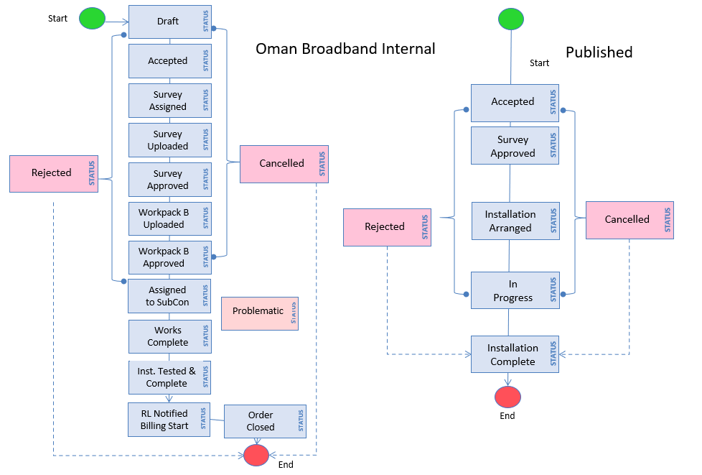
Figure ‎3.1: Status flow for a Connect Order

The order may be cancelled or rejected at different status points, as illustrated above. An order may only be cancelled at the request of the Requesting Licensee. In the event of rejection, OBB will provide a clear justification to the Requesting Licensee, detailing the reason for the rejection. Where the Requesting Licensee does not agree with OBB’s justification it can escalate the matter to the TRA as a dispute

A more detailed summary of Oman Broadband’s Internal and Published Status categories are provided in the table below:
Internal Status | Published Status | Description
Draft |  | Draft order record entered into Oman Broadband system.
Order Accepted | Accepted | Order validated by SOC and data entered in OM System.
Order Rejected (by Oman Broadband) | Rejected | Can occur at many points. Order may have inaccurate data or End-User may not be contactable or may refuse admission. Requesting Licensee may re-submit order.
Survey Arranged | Survey Arranged | The SOC has contacted End-User and arranged a slot for survey.
Survey Complete | In Progress | Oman Broadband’s site technician has completed the survey and gained acceptance of the works from End-User. The technician has also completed first part of the Works Instructions.
Workpack Complete | In Progress | Oman Broadband planning team has completed second part of the Works Instructions, added to the first part, and forwarded to manager for approval.
Workpack Approved | In Progress | Manager approves the works.
Workpack Received | In Progress | Sub-contractor acknowledges receipt of Works Instructions.
Installation/ Modification Complete | Complete | Installation tested and accepted by Oman Broadband, and billing begins.
Order Closed | Complete | Order closed.
Order Cancelled (by Requesting Licensee) | Cancelled | Cancelled by Requesting Licensee.
Problematic | Problematic | Order which has encountered an issue during delivery, and which may result in delay. Typical example is End-User not responding.

Message notifications will be provided as system-to-system messages through APIs provided by Requesting Licensee, as part of systems integration, or by email, and will provide information concerning the status of the order. Notifications will be sent for individual orders as they progress through the order journey.

Messages are exchanged through web-based APIs, provided by the respective Parties. Message 1 refers to the Order request received and processed by Oman Broadband. Messages 2 to 7 are notifications sent by Oman Broadband to Requesting Licensee.

As the order is progressed its status will change according to Figure ‎3.1.

Figure ‎3.2 outlines the order process and exchange of notifications between the Parties.

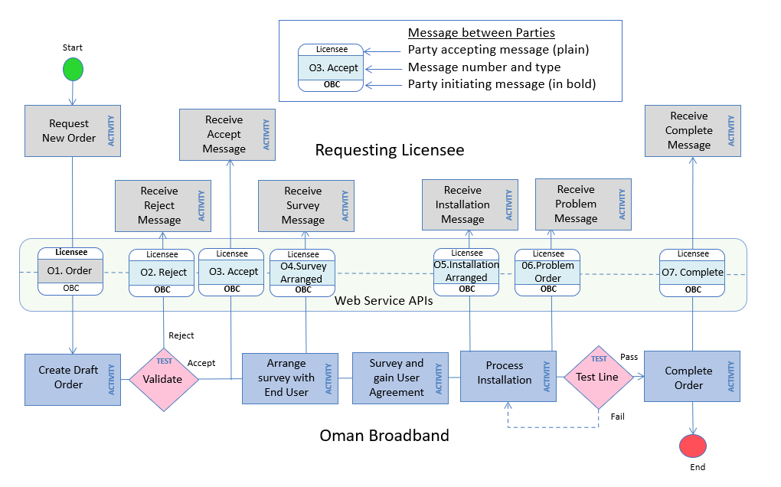
Figure ‎3.2: Exchange of notifications for a Connect Order

The information contained in each of the respective messages exchanged during the Connect Order is shown in the table below. The information will be delivered to Requesting Licensee using email, in the first instance. Service will be deemed to have started when an Order Complete message is submitted to Requesting Licensee.
Status to trigger notification message | Message no. | Information provided
Draft Order | O1 | Request for new Order is placed and a draft order is created in Oman Broadband system
Order Rejected | O2 | Requesting Licensee reference number  Field with reason for rejection
Order Accepted | O3 | Requesting Licensee reference number  Oman Broadband reference number  Date and time order accepted
Survey Arranged | O4 | Requesting Licensee reference number  Oman Broadband reference number  Date and time of survey
Installation Arranged | O5 | Requesting Licensee reference number  Oman Broadband reference number  Date and time of planned installation  Update End-User tag
Problematic Order | O6 | Requesting Licensee reference number  Oman Broadband reference number  Details of Problem
Installation Complete | O7 | Requesting Licensee reference number  Oman Broadband reference number  Date and time of completion  Network routing information  Received optical power level from test
* Notifications provided by system messages or by email

Basic End-User Connection (BEUC) Modify Orders

In certain circumstances, End-User may wish for a modification to its environment, for example re-positioning the CAP to a different location, or even re-routing of the conduit and fibre cable across its Premises.

Oman Broadband allows Requesting Licensee to place a request for the modification as a Modify Order, and Oman Broadband will charge for this order, as described in Annex E. Any modification requested by the End User in its own house or office is considered a Modify Order.”.

The information required by Oman Broadband to deliver a Modify Order for a BEUC Service is shown below. The information may be provided through a set of APIs from Oman Broadband or by email.
Field | Description
Product* | BEUC
Order Type* | Modify
Tag* | The tag identifier obtained from the GIS files of the footprint
Requesting Licensee reference number* | New reference number provided by Requesting Licensee (not pertaining to original connection order)
Oman Broadband reference number for original Connect Order | Oman Broadband reference return from original connection order (if possible)
End-User name | Contact name
End-User GSM* | Mobile number to contact for appointment
Date and time that order is submitted by Requesting Licensee | Date: day/month/year (xx/xx/xxxx)  Time: hour/minute (xx:xx)
Details of modification required* | Free field for requirements
* Mandatory fields

The status flow diagram for a Modify Order is the same as for a Connect Order (the latter is shown in Figure ‎3.1). These are the status flows that the order moves through during the workflow process. Only the Published Status will be referred to Requesting Licensee. The ‘In Progress’ status refers to several internal status changes whilst the order is being processed by Oman Broadband. Notification of the Order status will be sent to Requesting Licensee, based on the Published Status.

The diagram outlining the Modify Order process, showing when notifications are exchanged, is the same as the Connect Order process shown in Figure ‎3.2.

The information contained in each of the respective messages exchanged during the Modify Order is similar to that described in Clause ‎3.13. The information may be provided through a set of APIs provided by Requesting Licensee, or by email.

Requesting Licensee may make available to its Customers (Oman Broadband End-Users) a Relocation service, for people wishing to re-locate property.

Oman Broadband shall support this Relocation service by installing (where applicable) a new Basic End-User Connection at the new End-User Premises, followed by disconnection of the existing End-User connection at the former Premises. The new End-User Premises must lie inside the Coverage Area.

Two separate orders should be submitted to Oman Broadband: a Disconnect Order (as per Clause ‎3.31) at the former Premises and a new Connect Order (as per Clause ‎3.3) at the new Premises.

Requesting Licensee shall make payment of the applicable charges in accordance with Annex E.

Service-Level Guarantees (SLGs) pertaining to End-User Relocation will be composed of standard Connect and Disconnect Order SLGs.

Basic End-User Connection (BEUC) ‘Connect with ONT’ Orders

A Connect with ONT Order is a Connect Order that also includes a request to install and activate the Optical Network Terminal (ONT).

The information required by Oman Broadband to deliver a Connect with ONT Order for a BEUC service is the same as for a Connect Order (described in Clause ‎3.1), but also includes additional information, as shown in the table below. The exact details of the additional information required may vary by Requesting Licensee according to the agreed process for ONT installation.
Field
Type of ONT
Serial number
Router details
IP address
MAC address
Internet package

The status flow diagrams for a Connect with ONT Order are similar to a Connect Order (the latter is shown in Figure ‎3.1), but with some additional status categories, such as ‘Service Activated’.

Figure ‎3.3: Status flow for a Connect with ONT Order

Service notifications for Connect with ONT are the same as for a Connect Order (see Clause ‎3.13), with one difference: the final notification, sent out at the Service Activated point of the process, also includes the ONT completion certificate. This certificate contains a more detailed list of the parameters used to set up the ONT, such as IP address, among others. The exact format of the ONT completion certificate is agreed with Re questing Licensee.

BEUC Disconnect Orders

A Disconnect Order is a request from Requesting Licensee to Oman Broadband to disconnect End-User from the network, generally following a request made by End-User to Requesting Licensee.

It is Oman Broadband’s policy to leave the CAP and End-User fibre cable in place following a Disconnect Order, and the works generally relate to routing activities within the main network.

The information required by Oman Broadband to deliver a Disconnect Order for a BEUC Service is shown below. The information may be provided through a set of APIs from Oman Broadband or by email.
Field | Description
Product* | BEUC
Order Type* | Disconnect
Tag* | The tag identifier obtained from the GIS files of the footprint
Requesting Licensee reference number* | Reference number provided by Requesting Licensee
Oman Broadband reference number for original Connect Order | Oman Broadband reference return from original connection order (if possible)
End-User name | Contact name
End-User GSM* | Mobile number to contact for appointment
Date and time that order is submitted by Requesting Licensee | Date: day/month/year (xx/xx/xxxx)  Time: hour/minute (xx:xx)
Comments | Free field for comments if required
* Mandatory fields

Figure ‎3.4 shows the status flow diagrams for the Disconnect Order. These are the status flows that the order moves through during the workflow process. Only the Published Status will be referred to Requesting Licensee. The ‘In Progress’ status refers to several internal status changes whilst the order is being processed by Oman Broadband. Notification of the Order status will be sent to Requesting Licensee, based on the Published Status.

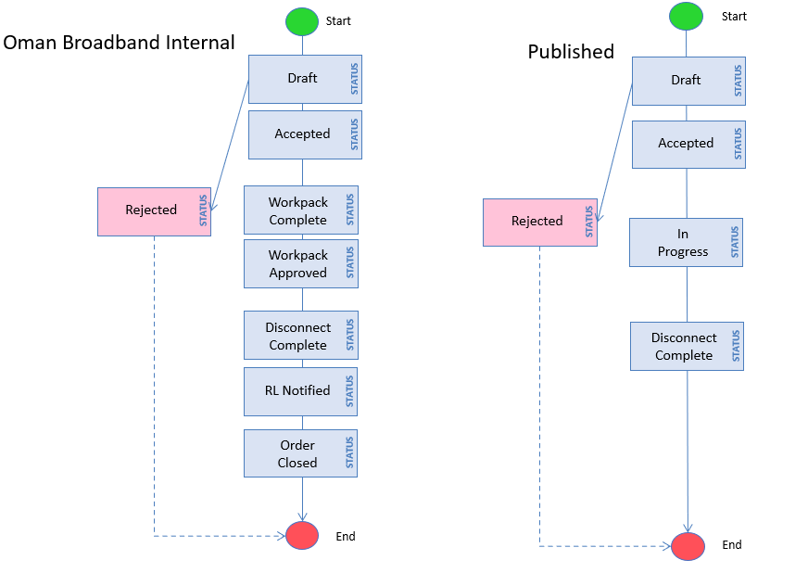
Figure ‎3.4: Status flows for a Disconnect Order

A more detailed summary of Oman Broadband’s Internal and Published Status categories is provided in the table below:
Internal Status | Published Status | Description
Draft |  | Draft order record entered into Oman Broadband system
Disconnect Order Accepted | Accepted | Order validated by SOC and data entered in OM System
Disconnect Order Rejected (by Oman Broadband) | Rejected | Can occur at many points. Order may have inaccurate data. Requesting Licensee may re-submit order.
Various activities | In Progress | Covers Oman Broadband activities required for Disconnect Order
Disconnect Complete | Complete | Works completed and billing ends subject to minimum contract period.
Order Closed | Complete | Order closed

Notifications will be provided to Requesting Licensee at various points during the order process. Message notifications will be sent by email to Requesting Licensee and will provide information concerning the Order status. An email will be sent for each individual message in the context of each order.

Figure ‎3.5 below outlines the Disconnect Order process and exchange of notifications. Message 1 refers to the Disconnect Order request received and processed by Oman Broadband. Messages 2 to 5 are notifications sent by Oman Broadband to Requesting Licensee.

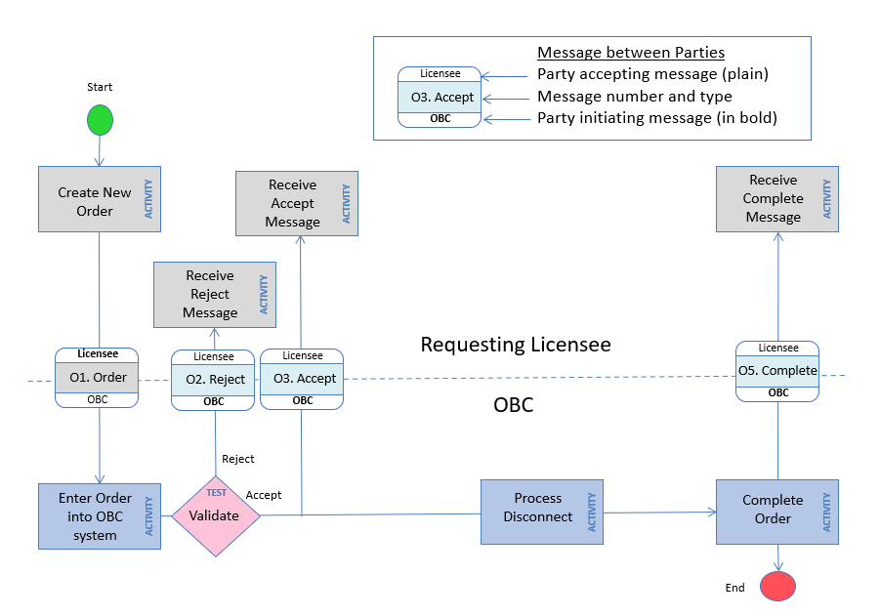
Figure ‎3.5: Exchange of notifications for a Disconnect Order

The information contained in each of the respective messages exchanged during the Disconnect Order is shown in the table below. The message numbers related to the messages illustrated in the diagram above. The information will be delivered to Requesting Licensee using email, in the first instance.
Status to trigger notification | Message No. | Information provided
(Order request) | O1 | Request for new Order is placed and a draft order is created in Oman Broadband system
Order Accepted | O3 | Requesting Licensee reference number  Oman Broadband reference number  Date and time order accepted
Order Rejected (by Oman Broadband) | O2 | Requesting Licensee reference number  Free field with reason for rejection
Disconnect Complete | O5 | Requesting Licensee reference number  Oman Broadband reference number  Date and time of completion  Comments field
* Notifications provided by email or into the systems of Requesting Licensee

BEUC Order Cancellations

Oman Broadband has made provision for Requesting Licensee to cancel In-Flight Connect and Modify Orders before they are complete.

Cancellations can only be initiated by Requesting Licensee.

An In-Flight Connect or Modify Order may be Cancelled by Requesting Licensee at any time before completion, but penalties may apply according to the table below.
Order status at Cancellation | Penalty incurred by Requesting Licensee
Order Accepted or Survey Arranged | No charge
Survey Complete or In Progress | Annex E
Install Complete | Disconnect Order

Once a Connect or Modify Order reaches Complete status, only a Disconnect Order will terminate or cancel the order. Oman Broadband does not allow the Cancellation of a Disconnect Order. If service is still required following the acceptance of a Disconnect Order, then a new Connect Order should be processed.

The information required by Oman Broadband to Cancel an In-Flight Connect or Modify Order for a BEUC Service is shown below. The Cancel request must pertain to an existing Order; if it does not, the request will be rejected by Oman Broadband. The information may be provided through a set of APIs from Oman Broadband or by email.
Field | Description
Product* | BEUC
Order Type* | Cancellation
Tag* | The tag identifier obtained from the GIS files of the footprint
Requesting Licensee reference number for original Connect or Modify Order* | Reference number provided to Requesting Licensee for original Connect or Modify Order
Oman Broadband reference number for original Connect or Modify Order | Oman Broadband reference return from original Connect or Modify Order
End-User name | Contact name
Date and time that order is submitted by Requesting Licensee | Date: day/month/year (xx/xx/xxxx)  Time: hour/minute (xx:xx)
Reason for cancellation | Free field
* Mandatory fields

Notifications are returned to Requesting Licensee at various points during the Cancellation process. Message notifications will be provided by email to Requesting Licensee and will provide information concerning the status of the order. An email will be sent for each individual message in the context of each order.

Figure ‎3.6 outlines the Cancel Order process and notifications exchange. Message 1 refers to the Cancel Order request received and processed by Oman Broadband. Messages 2 to 4 are notifications sent by Oman Broadband to Requesting Licensee.

Figure ‎3.6: Exchange of notifications for a Cancel Order

The information contained in each of the respective messages exchanged during the Cancel Order is shown in the table below. The message numbers relate to the messages illustrated in Figure ‎3.6.
Status to trigger notification | Message No. | Information provided
(Cancellation Request) | O1 | Request for Cancel Order is placed
Cancellation Rejected (by Oman Broadband) | O2 | Requesting Licensee reference number  Free field with reason for rejection
Cancellation Accepted (by Oman Broadband) | O3 | Requesting Licensee reference number  Free field
Cancellation Complete | O4 | Requesting Licensee reference number  Oman Broadband reference number  Date and time cancellation complete
* Information will be delivered to Requesting Licensee using email, in the first instance.

BEUC Order Rejections

All BEUC Order types may be rejected by Oman Broadband at any time before completion of the order due to any of the following reasons:
Reason for Rejection | Order status at rejection
Incomplete information on order form | Received
Inaccurate data on order form | Order Accepted
Unable to contact End-User for appointment after repeated attempts | Order Accepted
End-User does not accept proposed works | Survey Arranged
Unable to gain access to Premises for installation | Workpack Complete

Oman Broadband will provide an explanation of the reason for rejection in the rejection acknowledgement. Oman Broadband will not charge for orders that are rejected.

The order will only be rejected if Oman Broadband is not able to continue with the order under reasonable circumstances.

Oman Broadband will attempt to contact End-User via call and text message three times over a period of 3 days. If there is no response, then the order will be rejected.

If Oman Broadband is not able to access the Customer Premises either for a survey or for an installation at the agreed appointment time, then the order will also be rejected.

In practice, Oman Broadband will on many occasions seek an alternative appointment slot.

A rejected order may be re-submitted by Requesting Licensees, once they are able to make contact with End-Users.

Orders may be rejected by Oman Broadband if more than three attempts are required to arrange the first survey.

Rejected orders shall be excluded from Service performance targets.

On occasion, simultaneous orders for connections to the same Customer may be received from different service providers, for example during the release of a new area. In such cases, specific procedures will be agreed with Requesting Licensee to handle these exceptions. Such procedures may include placing the order on hold until confirmation to proceed is obtained from Requesting Licensee. Such cases may be discussed during Governance Meetings. The frequency of Governance Meetings will be agreed on by both Parties and will be finalized in the first Governance Meeting.

Service Orders: Co-location

The information required to place a Co-location Order is shown in the table below:
Field
Data Centre location
Date required
Type of co-location required (e.g. Secure Cage Space or Shared Co-location Space, either indoor or outdoor)
Space required if Shared Co-location Space
Details of equipment to be co-located
People to be authorised for site access
Proof of competence
Backhaul connections already ordered
Cable termination requirements, if any

Orders may generally be placed once the Data Centre site is declared Ready For Service (RfS), subject to approval for use and feasibility by Oman Broadband, on a case by case basis, although pre-orders may be accepted.

In the event that Co-location Space is unavailable, this will be communicated to Requesting Licensee.

The service shall be deemed to have commenced once access to the Co-location Space is granted, assuming that power is available.

There will be no automatic acceptance, rejection or cancellation of these orders.

Status updates will be communicated to Requesting Licensee on an ad-hoc basis either by email or phone call, or during Governance Meetings.

Service Orders: Duct Access

The information required to place a Duct Access Order is shown in the table below:
Field
Details of the duct route requested
Details of the end-points of the Sub-Duct
Details of handover points
Preferred delivery dates
Details of the connecting duct
Details of handholes to be installed by Requesting Licensee
Details of Fibre Optic cables that would be installed in the Sub-Duct
Confirmation that the Duct will be used for FTTH Access services

Following a Duct-Access Order request, Oman Broadband will acknowledge receipt of the Order within 5 Business Days.

Oman Broadband will inform Requesting Licensee whether the request is reasonable and if any additional information is required.

Further, Oman Broadband will conduct a feasibility study to confirm whether it is possible to connect the end-points as requested by Requesting Licensee. The feasibility study will consist of two survey stages:

The first survey will involve a desktop review of records stored within the systems;

If the first survey does not reveal any issues or exemptions, a field survey will be conducted, which will include a visit by field engineers to inspect the duct routes involved.

Once the survey stages are completed, a feasibility report will be sent to Requesting Licensee, outlining the feasibility of providing Sub-Duct in the specifies route(s).

The feasibility report will provide estimates of delivery dates, assuming that all works required by Requesting Licensee are completed prior to installation of Sub-Duct.

Indicative pricing would also be provided, subject to the terms outlined in Annex E.

For the avoidance of doubt, maps of duct routes built and utilized by Oman Broadband will not be provided to Requesting Licensee for security reasons.
For the Access to Oman Broadband Ducts, Oman Broadband shall target to deliver the Service within seventy (70) Working Days for a maximum of 2,000 running meter. The timeline for delivery of service exceeding 2,000 running meter shall be discussed on a case-by-case basis depending on request.

Responsibilities of each party and any exclusions to the service offering are provided in Sub-Annex B3.

Raising a Trouble Ticket

This Clause ‎8 describes the activities and procedures for Requesting Licensee to raise Trouble Tickets for faults relating to Oman Broadband products. It discusses the information flows required to process Trouble Tickets and to receive acknowledgements from Oman Broadband on the Ticket Status.

Assurance Support

First-line support will be offered from the Network Operations Centre (NOC) on a 24-hours-a-day, 7 days-a-week basis.

Requesting Licensee may raise Trouble Tickets at any time using the B2B Gateway or email/telephone, as defined in Annex G.

The NOC will be operational continuously.

Before reporting the fault to Oman Broadband, it is Requesting Licensee’s responsibility to determine the source of the fault at its own cost and to ensure that the fault does not lie within its network.

Oman Broadband provides monitoring of network-related alarms in Oman Broadband NOC on a 24-hours-a-day, 7 days-a-week basis.

An alarm results in the immediate creation of a Trouble Ticket in order to clear the issue.

Requesting Licensees may also request Trouble Tickets with Oman Broadband due to complaints received from End-Users.

Requesting Licensee should only raise a Trouble Ticket with Oman Broadband once it has determined that the issue lies in Oman Broadband domain.

Types of Trouble Ticket

There are different types of Trouble Ticket which may be raised for Oman Broadband products:

BEUC: Individual End-User connection incidents reported by Requesting Licensee:

Residential;

Business;

Co-location Type: Individual Co-location Service incidents reported by Requesting Licensee;

Duct Access Type: Duct Access Service incidents reported by Requesting Licensee;

Network Type: Incidents reported by Requesting Licensee or an Oman Broadband source for general network incidents impacting multiple users.

Prioritisation of Trouble Tickets

Each type of Trouble Ticket will be handled differently by Oman Broadband and will receive a different priority, with 1 being the highest priority and 3 being the lowest priority.
Type of Trouble Ticket | Priority Assigned
Network | 1
Duct Access | 1
BEUC: Business | 2
Co-location | 2
BEUC: Residential | 3

BEUC Service Trouble Tickets

The information required by Oman Broadband to raise a Trouble Ticket for a BEUC Service is shown below. The information may be provided by email or using a works order system provided by Requesting Licensee, providing Oman Broadband has access to the system.
Field | Description
Trouble ticket type* | End-User
End-User type* | Residential, Business,
Tag* | The tag identifier obtained from the GIS files of the footprint
Requesting Licensee reference number* | "Requesting Licensee reference number" refers to a unique identifier or code associated with the licensee who is making a specific request. It serves as a means of tracking and referencing the request made by that particular licensee. The "Oman Broadband reference number" is a separate identifier used internally to manage and track the request more broadly within the system.
Oman Broadband reference number for original BEUC Order | Oman Broadband reference return from original Connect Order
End-User name | Contact name
End-User GSM* | Mobile number to contact for appointment
Date and time that ticket is submitted by Requesting Licensee | Date: day/month/year (xx/xx/xxxx)  Time: hour/minute (xx:xx)
Details of fault diagnosis from Requesting Licensee* | - Time fault occurred  - Nature of fault (e.g. End-User reports no service)  - Location of fault (if possible)  - Are other users also affected and if so, how many?  - Results of Requesting Licensee diagnostic tests  - Reason why ticket raised to Oman Broadband  - Free field for other information, if relevant
* Mandatory fields

Once a diagnosis is made Requesting Licensee will be notified of the results and will be provided with an estimate of the time required to resolve the issues.

Figure ‎8.1 shows the status flow diagrams for the BEUC Trouble Ticket. These are the status flows that the ticket moves through during the workflow process. Only the Published Status will be referred to Requesting Licensee. The ‘In Progress’ status refers to several internal status changes whilst the ticket is being processed by Oman Broadband. Notifications of the Ticket Status will be sent to Requesting Licensee, based on the Published Status.

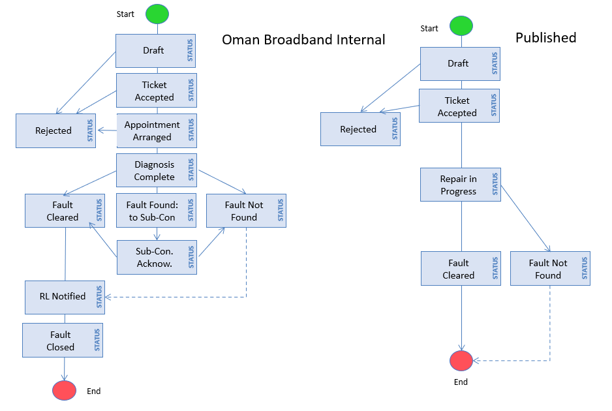
Figure ‎8.1: Status flows for BEUC Trouble Ticket

A more detailed summary of Oman Broadband’s Internal and Published Status categories are provided in the table below:
Internal Status | Published Status | Description
Draft |  | Draft ticket record entered into Oman Broadband system.
Ticket created | Ticket created | Ticket validated by NOC and data entered in FM System.
Ticket Rejected (by Oman Broadband) | Rejected | Can occur at many points. Ticket may have inaccurate data or End-User may not be contactable or may refuse admission. Requesting Licensee may re-submit order.
Appointment Arranged | Diagnosis Complete | The NOC has contacted End-User and arranged a slot for fault investigation, as well as assigning Oman Broadband engineer.
Diagnosis Complete | Diagnosis Complete | Oman Broadband’s site technician has visited the site and diagnosed the problem.
Assigned to Sub-contractor | In Progress | The NOC agent has forwarded the ticket to sub-contractor to process.
Sub-contractor Acknowledges | In Progress | Sub-contractor acknowledges receipt of Ticket.
Fault Not Found | Fault Not Found | After testing, the Network is found to have no fault.
Fault Cleared | Fault Cleared | Works are complete and network tested.
Requesting Licensee Notified | Fault Cleared | Status update sent to Requesting Licensee.
Ticket closed | Fault Cleared | Ticket closed.

Notifications will be returned to Requesting Licensee at various points during the ticket process. Message notifications will be provided by email to Requesting Licensee and will provide information concerning the status of the ticket. An email will be sent for each individual message that relates to a particular ticket.

Figure ‎8.2 outlines the ticket process and notifications exchange. Requesting Licensee is represented at the top of the diagram and Oman Broadband is represented at the bottom. Message 1 refers to the Trouble Ticket request received and processed by Oman Broadband. Messages 2 to 5 are notifications sent by Oman Broadband to Requesting Licensee.

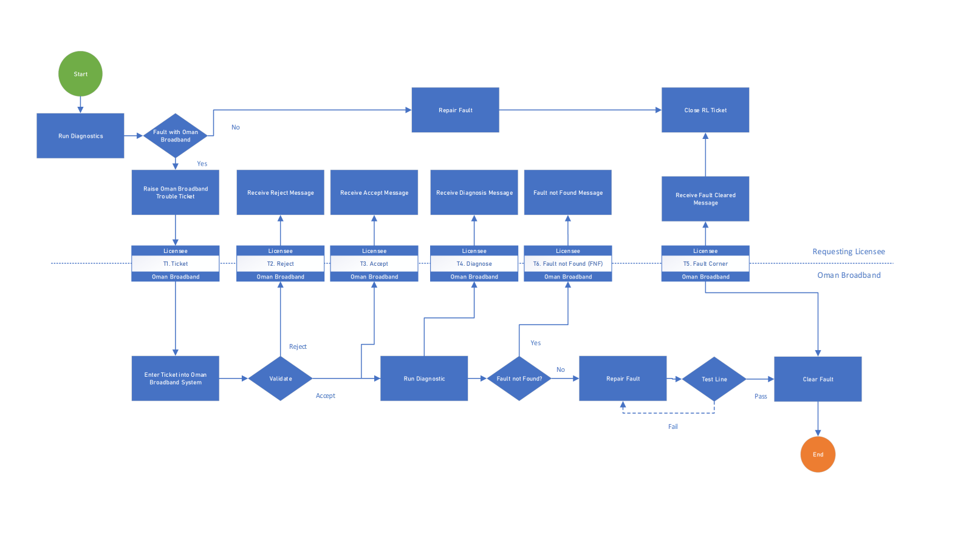
Figure ‎8.2: BEUC Trouble Ticket process and exchange of notifications

Figure ‎8.2 also shows the requirement that Requesting Licensee first conducts a test to determine if the fault lies with Oman Broadband’s network or within Requesting Licensee’s own network.

If a trouble ticket is raised and no fault is found within Oman Broadband, then Requesting Licensee will be notified as per Clause ‎8.44.

The information contained in each of the respective messages exchanged during the Trouble Ticket process is shown in the table below. The message numbers relate to the messages illustrated in Figure ‎8.2 above. The information will be delivered to Requesting Licensee using email, in the first instance.
Status to trigger notification | Message No. | Information provided
(Raise Ticket) | T1 | Raise Trouble Ticket with Oman Broadband
Ticket Rejected (by Oman Broadband) | T2 | Requesting Licensee reference number  Free field with reason for rejection
Ticket Accepted | T3 | Requesting Licensee reference number  Oman Broadband ticket reference number  Date and time ticket accepted  Date and time of End-User appointment
Diagnosis Complete | T4 | Requesting Licensee reference number  Oman Broadband ticket reference number  Time to attend site  Free field for diagnosis  Estimated time to restore
Fault Cleared | T5 | Requesting Licensee reference number  Oman Broadband reference number  Received optical power level from test
Fault Not Found | T6 | Requesting Licensee reference number  Oman Broadband reference number  Received optical power level from test
* Notifications provided by email or into the systems of Requesting Licensee, if available

Co-location Trouble Tickets

The information required to raise a Co-location Trouble Ticket is shown in the table below:
Field | Description
Trouble ticket type* | Co-location
Requesting Licensee reference number* | Requesting Licensee reference number" refers to a unique identifier or code associated with the licensee who is making a specific request. It serves as a means of tracking and referencing the request made by that particular licensee.  The "Oman Broadband reference number" is a separate identifier used internally to manage and track the request more broadly within the system.
Oman Broadband Order Reference | Details of the Original Oman Broadband order reference that was given at the time of provision
End Points | Cable A/B End or Data Centre location
Fibre identifier | Identification of specific fibre
Date and time that ticket is  submitted by Requesting Licensee | Date: day/month/year (xx/xx/xxxx)  Time: hour/minute (xx:xx)
Details of incident* | Free field
Details of fault diagnosis by Requesting Licensee* | - Time fault occurred  - Nature of fault  - Location of fault (if possible)  - Free field for other information, if relevant
* Mandatory fields

Since the activities within the Secure Cage Space are under the control of Requesting Licensee, it is also responsible for any damage caused within this area.

There will be no automatic acceptance, rejection or cancellation of these Trouble Tickets. Status updates will be communicated to Requesting Licensee either by email or phone call.

Once a diagnosis is made Requesting Licensee will be notified of the results and will be provided with an estimate of the time required to resolve the issues

Duct Access Trouble Tickets

The information required to raise a Duct Access Trouble Ticket is shown in the table below:
Field | Description
Trouble ticket type* | Duct Access
Requesting Licensee reference number* | Requesting Licensee reference number" refers to a unique identifier or code associated with the licensee who is making a specific request. It serves as a means of tracking and referencing the request made by that particular licensee.  The "Oman Broadband reference number" is a separate identifier used internally to manage and track the request more broadly within the system.
Oman Broadband Order Reference | Details of the Original Oman Broadband order reference that was given at the time of provision
End Points | A/B End or location
Date and time that ticket is  submitted by Requesting Licensee | Date: day/month/year (xx/xx/xxxx)  Time: hour/minute (xx:xx)
Details of incident* | Free field
Details of fault diagnosis by Requesting Licensee* | - Time fault occurred  - Nature of fault  - Location of fault (if possible)  - Free field for other information, if relevant
* Mandatory fields

Once a diagnosis is made Requesting Licensee will be notified of the results and will be provided with an estimate of the time required to resolve the issues.

Following resolution of the complaint, a subsequent notification will be sent to Requesting Licensee.

Network Incident Trouble Tickets

On occasions Requesting Licensee may suffer a network incident fault that may impact a large number of End-Users within one area at the same time. For example a fault in the feeder network may impact a whole FDH with >32 end-users.In such cases, Oman Broadband will accept a Network Incident Trouble Ticket.

The information required by Oman Broadband to raise a Trouble Ticket for a Network Incident is shown below. The information may be provided by email or using a works order system provided by Requesting Licensee, providing Oman Broadband has access to the system.
Field | Description
Trouble ticket type* | Network Incident
Description of Incident* | Free field
Requesting Licensee reference number* | Requesting Licensee reference number" refers to a unique identifier or code associated with the licensee who is making a specific request. It serves as a means of tracking and referencing the request made by that particular licensee.  The "Oman Broadband reference number" is a separate identifier used internally to manage and track the request more broadly within the system.
Date and time that ticket is submitted by Requesting Licensee | Date: day/month/year (xx/xx/xxxx)  Time: hour/minute (xx:xx)
Details of fault diagnosis by Requesting Licensee* | Free field
* Mandatory fields

Network Incident tickets take priority over End-User tickets in Oman Broadband systems, therefore a full description of the incident together with a summary of the preliminary diagnosis by Requesting Licensee must be provided. Failure to do so may result in a rejection of the ticket.

Figure ‎8.3 shows the status flow diagrams for the Network Incident Trouble Ticket. These are the status flows that the ticket moves through during the workflow process. Only the Published Status will be referred to Requesting Licensee. The ‘In Progress’ status refers to several internal status changes whilst the ticket is being processed by Oman Broadband. Notifications of the Ticket Status will be sent to Requesting Licensee based on the Published Status.

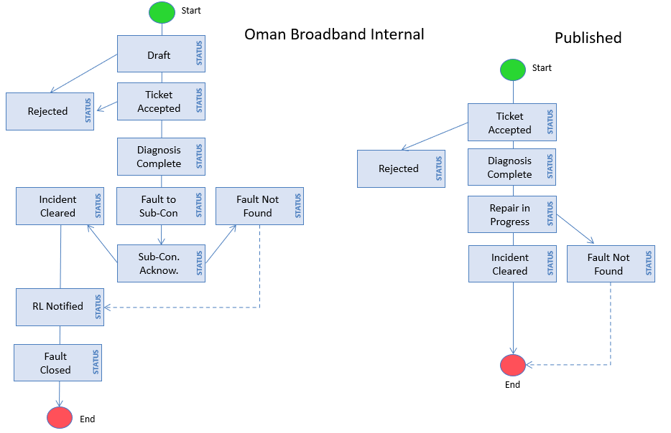
Figure ‎8.3: Status flows for Network Incident Trouble Ticket

A more detailed summary of Oman Broadband’s Internal and Published Status categories are provided in the table below:
Internal Status | Published Status | Description
Draft |  | Draft ticket record entered into Oman Broadband system.
Ticket accepted | Ticket accepted | Ticket validated by NOC and data entered in FM System.
Ticket Rejected (by Oman Broadband) | Rejected | Can occur at many points. Ticket may have inaccurate data or End-User may not be contactable or refuse admission. Requesting Licensee may re-submit order.
Diagnosis Complete | Diagnosis Complete | Oman Broadband’s site technician has visited the site and diagnosed the problem.
Assigned to Sub-contractor | In Progress | The NOC agent has forwarded the ticket to sub-contractor to process.
Sub-contractor Acknowledges | In Progress | Sub-contractor acknowledges receipt of ticket.
Fault Not Found | Fault Not Found | After testing, the Network is found to have no fault.
Fault Cleared | Fault Cleared | Works are complete and network tested.
Requesting Licensee Notified | Fault Cleared | Status update sent to Requesting Licensee.
Ticket Closed | Fault Cleared | Ticket closed.

Notifications are exchanged in the same way as for the BEUC Trouble Ticket shown in Figure ‎8.2.

The information contained in each of the respective messages exchanged during the Network Incident Trouble Ticket is shown in the table below. The information will be delivered to Requesting Licensee using email, in the first instance.
Status to trigger notification | Message No. | Information provided
(Raise Ticket) | T1 | Draft ticket record entered into Oman Broadband system.
Ticket Rejected (by Oman Broadband) | T2 | Requesting Licensee reference number  Free field with reason for rejection
Ticket Accepted | T3 | Requesting Licensee reference number  Oman Broadband ticket reference number  Date and time ticket accepted
Diagnosis Complete | T4 | Requesting Licensee reference number  Oman Broadband ticket reference number  Time to attend site  Free field for diagnosis  Estimated time to restore
Fault Cleared | T5 | Requesting Licensee reference number  Oman Broadband reference number  Free field of details of incident
Fault Not Found | T6 | Requesting Licensee reference number  Oman Broadband reference number  Free field with evidence of Fault Not Found (FNF)

Requesting Licensee acknowledges that Oman Broadband may temporarily disconnect Requesting Licensee’s BEUC to perform reasonable fault analysis and line testing on the BEUC. Oman Broadband shall conduct such disconnection only as it reasonably considers necessary.

The BEUC is deemed to be restored when Oman Broadband has delivered a Fault Cleared message to Requesting Licensee. Oman Broadband will notify Requesting Licensee on the cause of the fault.

Fault Not Found (FNF) or Damage Caused by End-User (DCEU)

If a Trouble Ticket is raised and after diagnosis by Oman Broadband no fault is found, then Requesting Licensee will be notified.

Additionally, if a Trouble Ticket is investigated and a fault is found that has been caused by End-User, through no fault of Oman Broadband, then a charge may be made according to Annex E.

DCEU includes any damage within End-User’s Premises to the fibre-optic cable or to the CAP, rendering the service inactive, once the cable has been installed and tested, through no fault of Oman Broadband. The types of damage include:

Damage to the conduit and enclosed fibre-optic cable across the courtyard between the boundary wall and the building, for example through civil works;

Damage to the internal conduit or fibre-optic cable within the building;

Obvious damage to the CAP causing a degradation to the service.

Notification messages will be returned to Requesting Licensee with FNF and DCEU information.

Faults categorised as FNF or DCEU will be excluded from performance measures and SLGs.

If Requesting Licensee wishes to dispute these findings, then a joint investigation may be held at the request of Requesting Licensee.
Fault Status | Penalty incurred by Requesting Licensee
FNF | Annex E
DCEU | Annex E

Cancellation of Trouble Tickets

Oman Broadband does not make provision for cancellation of Trouble Tickets. Once a ticket is accepted, it will be processed according to the relevant workflows.

If Requesting Licensee asks that an In-Flight Trouble Ticket be cancelled, its status will be set to FNF by Oman Broadband.

Service Ordering and Provisioning/Delivery KPIs and SLGs

This Clause ‎9 sets out the service ordering, provisioning, delivery measures (KPIs) and the targets that Oman Broadband has set with respect to these measures, in accordance with Annex-1 of the A&I Regulation as defined in Annex A of this Agreement. Oman Broadband will report its performance against these KPIs as part of the Governance Meetings. The frequency of Governance Meetings will be agreed on by both Parties and will be finalized in the first Governance Meeting.

In addition, this Clause also sets out the SLGs that Oman Broadband commits to meet in respect of it Regulated Services. Not all KPIs are offered as SLGs. SLGs would be discussed as a part of the Governance Meetings.

A failure by Oman Broadband to meet any Service Ordering and Provisioning/Delivery target or SLG does not constitute a breach of the Agreement but there are remedial actions which Oman Broadband will follow as defined in clause ‎14 of this Annex.

All SLG’s would be measured excluding travel time per region, scheduled service interruptions and occurrence of any force majeure event, where applicable. The travel time per region is defined as below:
Region/Governorate | Maximum Travel Time
Muscat | 2 hours
Al Batinah South | 3 hours
Al Batinah North | 5 hours
Al Dakhliya | 4 hours
Al Sharqiya North | 4 hours
Al Sharqiya South | 6 hours
Al Dhahirah | 5 hours
Al Bureymi | 5 hours
Musandam | 8 hours
Al Wusta | 8 hours
Dhofar | 12 hours

We also note here the new procedure initiated by the Telecommunications Regulatory Authority (TRA) to monitor compliance to the QoS KPIs for fixed services, originally defined in TRA Resolution No 28/16; Issuing Quality of Service Requirements. This new procedure was outlined in QoS Regulation , and stipulates that passive infrastructure providers, such as Oman Broadband, also make records available to TRA in the event of an audit of the QoS KPIs, and report the reasons for any non-compliance; the KPI’s target values are to be recorded and reported to TRA (with justification and supporting proof), in order to ascertain the reasons and circumstances causing the delays.

Following an Order request, Oman Broadband will acknowledge receipt of the Order within 2 Business Days.

Access Provider shall, at the latest within five (5) Working Days after receiving the Order, inform Access Seeker about the Delivery Due Date (DDD) as part of the Delivery Order Offer (DOO).”

The Delivery Order Offer is valid for (10) ten working days unless and otherwise specified in the Delivery Order Offer.”.

The Percentage of faults reported per line per year is less <10% measured as the total number of faulty lines (not caused by factors outside Oman Broadband’s control) against total lines per year.”.

BEUC Service Ordering and Provisioning/Delivery KPIs

Oman Broadband has defined five KPIs to assess the performance of its BEUC Service Ordering and Provisioning/Delivery processes:
KPI | Description
KPI1 | Time to acknowledge order
KPI2 | Time to arrange survey (Survey Assigned)
KPI3 | Time to complete Survey from accepted status
KPI4 | Time to complete Order from accepted status
KPI5 | Time to complete Order from acceptance to delivery

These KPIs are illustrated below in Figure ‎9.1 with respect to Order status. Some KPIs will be offered as SLGs, and all KPIs will be reported on at Governance Meetings.

Figure ‎9.1: BEUC Service Ordering and Provisioning/Delivery KPIs
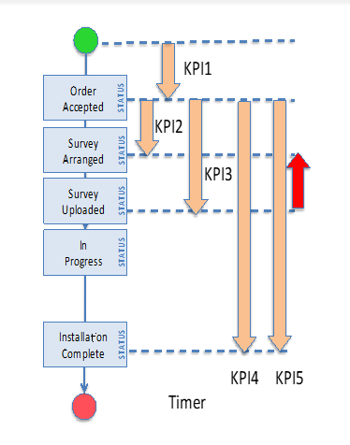

BEUC Service Ordering and Provisioning/Delivery SLG for Connect Order

The SLG for BEUC Service provision Connect Order is defined as follows:
SLG | KPI | Measure* | Target/threshold
SLG1 | KPI5 | Time to complete order from acceptance to delivery assuming unrestricted access to site | 90% <= 9 Business Days**
* Assessed on a quarterly basis
* Excludes travel time, scheduled service interruptions and occurrence of any Force Majeure event
** Business Hours/day:
  - For responding to order: 09.00–17.00, Sunday to Thursday
  - For installation, including engineering visits to End-User site: appointments arranged between 08.00 and 20.00, Saturday to Thursday

BEUC Service Ordering and Provisioning/Delivery SLG for Connect with ONT Order

Since Connect with ONT Orders require an additional stage to be undertaken, namely ONT installation, one extra day will be added to SLG1. The extra day is to allow for many cases where there is a delay between installation of the FTTH connection (Connect Order) and the installation and activation of the ONT on behalf of Requesting Licensee.
SLG | KPI | Measure* | Target/threshold
SLG1 | KPI5 | Time to complete order from acceptance to delivery assuming unrestricted access to site | 90% <= 10 Business Days**
* Assessed on a quarterly basis
* Excludes travel time, scheduled service interruptions and occurrence of any Force Majeure event
** Business Hours/day:
  - For responding to order: 09.00–17.00, Sunday to Thursday
  - For installation, including engineering visits to End-User site: appointments arranged between 08.00 and 20.00, Saturday to Thursday

Since the placement of a Connect with ONT Order reduces the activities required by Requesting Licensee to complete its end-to-end process, the inclusion of an extra day within the SLG does not impact the QoS KPIs required of Requesting Licensee by the TRA.

BEUC Service Ordering and Provisioning/Delivery SLGs for Modify Order

SLGs are not provided for the Service provision of Modify Orders.

However, KPIs are defined according to Clause ‎9.1, with a target for the delivery of Modify Orders equal to the SLGs defined in Clause ‎9.8 and Clause ‎9.9.

KPIs may be shared with Requesting Licensee at relevant Governance Meetings.

Duct Access Service Ordering and Provisioning/Delivery KPIs

Oman Broadband has defined the following KPI to assess the performance of its Duct Access Service Ordering and Provisioning/Delivery processes:
KPI | Description
KPI6 | Time to acknowledge order

The The Service Agreement will detail the specific terms and conditions agreed upon by both parties.

Colocation Service Ordering and Provisioning/Delivery SLG

The SLG for Colocation Service provision is defined as follows:

SLG | KPI | Measure* | Target/threshold
SLG1 | KPI5 | Time to complete order from acceptance to delivery assuming unrestricted access to site | 25-70 working days
* Assessed on a quarterly basis
* Excludes travel time, scheduled service interruptions and occurrence of any Force Majeure event
** Business Hours/day:
  - For responding to order: 09.00–17.00, Sunday to Thursday
  - For installation, including engineering visits to End-User site: appointments arranged between 08.00 and 20.00, Saturday to Thursday

Fault Reporting/Repair KPIs and SLGs

This Clause ‎10 sets out the fault reporting/repair (KPIs) and the targets that Oman Broadband has set with respect to these measures, in accordance with Annex-1 of the A&I Regulation as defined in Annex A of this Agreement. Oman Broadband will report its performance against these KPIs as part of the Governance Meetings. The frequency of Governance Meetings will be agreed on by both Parties and will be finalized in the first Governance Meeting.

In addition, this Clause also sets out the SLGs that Oman Broadband commits to meet in respect of it Regulated Services. Not all KPIs are offered as SLGs. SLGs would be discussed as a part of the Governance Meetings.

A failure by Oman Broadband to meet any fault reporting/repair target or SLG does not constitute a breach of the Agreement but there are remedial actions which Oman Broadband will follow as defined in clause ‎14 of this Annex.

All SLG’s would be measured excluding travel time per region, scheduled service interruptions and occurrence of any force majeure event, where applicable. The travel time per region is as defined in Clause ‎9.4.

We also note here the new procedure initiated by the Telecommunications Regulatory Authority (TRA) to monitor compliance to the QoS KPIs for fixed services, originally defined in TRA Resolution No 28/16; Issuing Quality of Service Requirements. This new procedure was outlined in QoS Regulation Decision No. (108/2022), and stipulates that passive infrastructure providers, such as Oman Broadband, also make records available to TRA in the event of an audit of the QoS KPIs, and report the reasons for any non-compliance; the KPI’s target values are to be recorded and reported to TRA (with justification and supporting proof), in order to ascertain the reasons and circumstances causing the delays.

BEUC fault reporting/repair KPIs

Oman Broadband has defined three KPIs to assess the performance of its Service assurance processes:
KPI | Description
KPI7 | Time to acknowledge Trouble Ticket
KPI8 | Time to attend fault site from Accepted status
KPI9 | Time to clear fault from acknowledgement of ticket, excluding time to appointment, assuming unrestricted access to site

These KPIs are illustrated below in Figure ‎10.1 with respect to Order status. Some KPIs will be offered as SLGs, and all will be reported on at Governance Meetings.

Figure ‎10.1: Fault reporting/repair KPIs

Residential, BEUC fault reporting/repair SLGs
SLG | KPI | Measure | Target/threshold
SLG2 | KPI7 | Time to acknowledge residential ticket* | 90% <= 2 Business Hours**
SLG3 | KPI9 | Time to clear fault from acknowledgement of ticket, assuming unrestricted access to site* | 95% <= 3 Business Days**
* Assessed quarterly
* Excludes travel time, scheduled service interruptions and occurrence of any Force Majeure event
**Business day: 09.00–17.00, Sunday to Thursday

Business BEUC fault reporting/repair SLGs
SLG | KPI | Measure | Target/threshold
SLG2 | KPI7 | Time to acknowledge ticket* | 90% <= 2 Business Hours**
SLG3 | KPI9 | Time to clear fault from acknowledgement of ticket, assuming unrestricted access to site* | 95% <= 3 Business Days**
* Assessed quarterly
* Excludes travel time, scheduled service interruptions and occurrence of any Force Majeure event
** Business day: 08.00–20.00, Saturday to Thursday

Duct Access fault reporting/repair KPI

Oman Broadband has defined the following KPI to assess the performance of its Duct Access Service:

SLG | KPI | Measure | Target/threshold
SLG2 | KPI7 | Time to acknowledge ticket* | 90% <= 2 Business Hours**
SLG3 | KPI9 | Time to clear fault from acknowledgement of ticket, assuming unrestricted access to site* | 95% <= 3 Business Days**

Resolution of Duct Access service complaints may require cooperation between Oman Broadband and Requesting Licensee.

The Service Agreement will detail the specific terms and conditions agreed upon by both parties.

Minimum QoS KPIs and SLGs

This Clause sets out the Minimum QoS (KPIs) and the targets that Oman Broadband has set with respect to these measures, in accordance with Annex-1 of the A&I Regulation as defined in Annex A of this Agreement. Oman Broadband will report its performance against these KPIs as part of the Governance Meetings. The frequency of Governance Meetings will be agreed on by both Parties and will be finalized in the first Governance Meeting.

In addition, this Clause also sets out the SLGs that Oman Broadband commits to meet in respect of it Regulated Services. Not all KPIs are offered as SLGs. SLGs would be discussed as a part of the Governance Meetings.

A failure by Oman Broadband to meet any Minimum QoS target or SLG does not constitute a breach of the Agreement but there are remedial actions which Oman Broadband will follow as defined in clause ‎14 of this Annex.

All SLG’s would be measured excluding travel time per region, scheduled service interruptions and occurrence of any force majeure event, where applicable. The travel time per region is as defined in Clause ‎7.4.

We also note here the new procedure initiated by the Telecommunications Regulatory Authority (TRA) to monitor compliance to the QoS KPIs for fixed services, originally defined in TRA Resolution No 28/16; Issuing Quality of Service Requirements. This new procedure was outlined in QoS Regulation as defined in Annex A of this Agreement, and stipulates that passive infrastructure providers, such as Oman Broadband, also make records available to TRA in the event of an audit of the QoS KPIs, and report the reasons for any non-compliance; the KPI’s target values are to be recorded and reported to TRA (with justification and supporting proof), in order to ascertain the reasons and circumstances causing the delays.

BEUC Minimum QoS SLGs
SLG | KPI | Measure | Target / Threshold
SLG4 | KPI10 | Service availability* | 99% offered over Business Days
SLG5 | KPI11 | Number of faults per line* | <10% (total number of faulty lines against total lines per year)
*Average value assessed annually
*Excludes travel time, scheduled service interruptions and occurrence of any Force Majeure event

Co-location Minimum QoS SLGs
SLG | KPI | Measure | Target / Threshold
SLG4 | KPI10 | Power availability* | >99.99% offered over a year
SLG5 | KPI11 | Cooling(temperature) availability  (indoor only)** | >99.9% cooling at below 25°C over a year
*Calculated as:
  - (A–B)/A x 100%, where A=Total power minutes per quarter; and, B=Total Minutes of down time, i.e., minutes per quarter where power is unavailable
  - Total power minutes do not include Scheduled Maintenance timeframes
  - Excludes travel time, scheduled service interruptions and occurrence of any Force Majeure event
**Calculated as:
  - (A–B)/A x 100%, where A=Total cooling minutes per quarter; and, B=Total Minutes of down time, i.e., minutes per quarter where cooling is unavailable
  - Total cooling minutes do not include Scheduled Maintenance timeframes
  - Cooling is measured by the average return air temperature of the active recirculation units within the Oman Broadband Data Centre
  - Excludes travel time, scheduled service interruptions and occurrence of any Force Majeure event

Billing KPIs and SLGs

All timelines and procedures associated with billing and settlement procedures in respect of Charges for Services are set out in Annex F of this Agreement.

Network Operation and Maintenance

This Clause sets out the Network Operation and Maintenance procedures and timelines that Oman Broadband and Requesting Licensee must adhere to for the operation and maintenance of their respective networks. This Clause shall comply with Annex-1 of the A&I Regulation and Clause 10 of the Main Agreement.

Oman Broadband shall provide Requesting Licensee with at least five (5) Business Days’ notice in advance of any Scheduled Maintenance that is not impacting the live service.

In addition, Oman Broadband shall provide Requesting Licensee with at least ten (10) Business Days’ notice in advance of any scheduled service interruption.

Oman Broadband shall take all reasonable steps to ensure that the interruption is minimised.

Information relating to scheduled Oman Broadband network works that may be service interrupting will be sent to Requesting Licensee via email and Oman Broadband will include the following details:

Affected location;

Date and time of occurrence; pursuant to clause 6.13, 6.24, 6.26

Duration of works;

Reason for works;

Likely impact of works.

Scheduled service interruptions will be excluded from Key Performance Indicator (KPI) measurements, as defined in Clauses ‎9,‎10 and ‎11.

For other maintenance procedures, refer to Clause 20 of the Main Agreement and individual service Sub-Annexes.

Procedures for non-compliance to SLGs

Oman Broadband shall report on a quarterly basis to the other Party, all KPIs (achieved and not achieved) of the previous quarter.

The quarterly report shall be sent by Oman Broadband to the Requesting Party within first ten (10) Working Days of the new quarter.

Non-compliance with any Service Level or KPIs by Oman Broadband, as set out in this RAIO, establishes the right of the Requesting Party to receive Service Credit in accordance with this Clause.

Where the non-compliance of Oman Broadband with any Service Level or KPIs is provided in the quarterly reports sent by Oman Broadband under Clause 14.2, the Requesting Party can raise a Service Credit Claim no later than thirty (30) Calendar Days after receiving such reports.

Where the Requesting Party monitors Quality of Service to measure the actual performance of Oman Broadband against the relevant Service Level or KPIs, and believes that Oman Broadband has not complied with Service Levels or KPIs, either it was omitted from quarterly reports of Oman Broadband or the Requesting Party is not agreeing with Service Level or KPIs reported by Oman Broadband in its quarterly reports, then the Requesting Party can raise a Service Credit Claim within thirty (30) Calendar Days of becoming aware of such non-compliance but in any case no later than sixty (60) Calendar Days after the end of the respective quarter.

Oman Broadband shall review, in good faith, the Requesting Party’s Service Credit Claim submitted to it and respond to the Requesting Party within a reasonable time frame, but in any case, no longer than thirty (30) Calendar Days following its submission by the Requesting Party, otherwise the Requesting Party’s Service Credit Claim will be deemed accepted by Oman Broadband.

If the Service Credit Claim submitted by the Requesting Party is accepted by Oman Broadband, then Oman Broadband shall apply the amount of that Service Credit, subject to any maximum caps, as a credit towards the Charges payable by the Requesting Party, for the billing period following such acceptance and, where required, for each subsequent period until the total amount of the applicable Service Credit (subject to maximum cap) has been applied in full.

If the Service Credit Claim submitted by the Requesting Party is not accepted by Oman Broadband, then Oman Broadband shall provide the reasons of its non-acceptance to the Requesting Party within the time frame provided in Clause 14.6 of Annex D. The Requesting Party, in case of disagreement with Oman Broadband may raise a dispute which shall be resolved in accordance with the Dispute Resolution Procedures mentioned in Clause 20 of the Main Agreement.

The amount of Service Credit shall be equal to:
• 5% × MRC (or the associated task fee in case of NRC services) × number of Days of delay, capped at a maximum of 20% MRC/NRC, for any of the provisioning SLAs/KPIs (e.g., delivery time)
• 1% × MRC × % of delay in fault handling processes, capped at a maximum of 20% MRC per month per line/user/site
• 1% × MRC × each 0.1% of availability below target (availability), capped at a maximum of 20% MRC per month per line/user/site, where the availability is measured per line or user or site depending on the type of service contracted.

The maximum cap applicable to the three items above shall increase linearly, each year, from 20% to 100% in 3 years from the publication of this RAIO, i.e., 20% in 2026, 60% in 2027, 100% in 2028 and onwards.

The Service Level or KPIs shall not apply in any of the following circumstances:
(i) The Service is disconnected or suspended under the terms and conditions of this Agreement, except where the suspension is due to Oman Broadband’s fault. However, upon reconnection of the Service, the respective Service Levels and KPIs shall be applicable;

(ii) Provision or restoration of the Service where any site-coordination meeting, Joint Investigation Meeting or fault identification coordination meeting is involved, except where the fault was caused by Oman Broadband and the Requesting Licensee has not contributed to any delay in setting up the meeting. (In determining whether the Service Level Guarantees have been met by Oman Broadband, the time taken from the start of arranging any site-coordination meeting, Joint Investigation Meeting or fault identification coordination meeting up to the end of the meeting shall always be excluded);

(iii) Problematic orders and trouble tickets, where the problem lies beyond the reasonable control of Oman Broadband, are also excluded. Such categories of problem include:

a) The End-User is not responding or is not reachable;

b) The End-User delays access to the premise concerned, for survey, installation or fault diagnosis purposes, or does not wish to proceed with the order;

c) The order is for a premise which is outside the coverage area provided by Oman Broadband;

d) The order is for a premise with multiple tenants, and where indoor NAPs are required, and which have not yet been provisioned;

e) Oman Broadband is unable to obtain or maintain any permission necessary to install its equipment in the premise concerned, or for the provision or restoration of the Service despite using its reasonable endeavours to obtain expeditiously or maintain such permissions. Such permissions may also include those required from the Municipalities for construction works. In determining whether the Service Level Guarantees have been met by Oman Broadband, the time taken by Oman Broadband to obtain or maintain any permission necessary to the provision or restoration of the Service shall always be excluded. Oman Broadband will provide evidence that it has used such reasonable endeavours;

f) Oman Broadband has difficulty accessing or working in the building or End-User’s Premise or at the fault site due to the building or premise being inaccessible, in unsafe working condition or in any other inadequate or deficient state despite using its reasonable endeavours to expeditiously remedy the building access difficulties, provided always that in the event that Requesting Licensee raises a dispute as to whether Oman Broadband has used its reasonable endeavours to expeditiously remedy the access difficulties, Oman Broadband will provide evidence that it has used such reasonable endeavours;

(iv) Delay in the provision or restoration of the Service caused by events beyond the reasonable control of Oman Broadband and its suppliers and contractors;

(v) Oman Broadband network outages for which Requesting Licensee has not reported a fault;

(vi) Fault is reported by Requesting Licensee, but no fault is found or confirmed after due and careful investigation, and verification by Oman Broadband;

(vii) Oman Broadband’s scheduled service interruption for which Requesting Licensee has been informed;

(viii) Force Majeure events.

Where Oman Broadband fails to achieve Service Levels or KPIs for three (3) consecutive periods (Repeat Failure), then the Requesting Party may serve notice on Oman Broadband informing Oman Broadband of that Repeat Failure. Oman Broadband shall, within thirty (30) Calendar Days after receiving such notice, provide a list of remedial actions specifying the measures Oman Broadband shall take, at no additional cost to the Requesting Party, to remedy the Repeat Failure and ensure that it does not recur (a Remediation Plan). The Requesting Licensee will be provided with an opportunity to comment on the Remediation Plan which shall be discussed in Governance Meetings.

